Case Study 2 Aarthi. P
Collection Attendence:

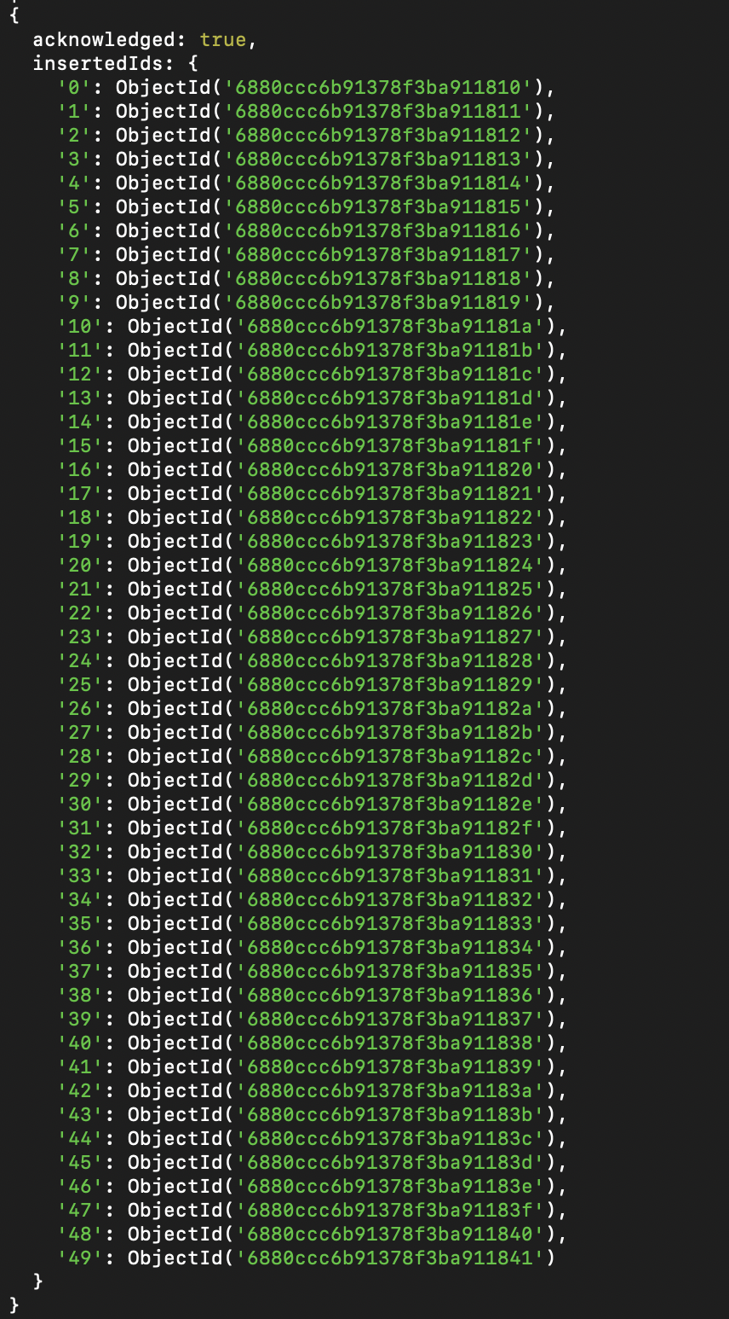

Collection Codekata:
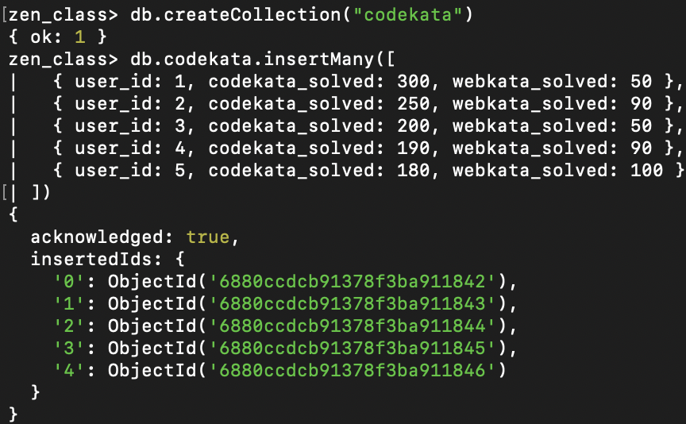

Collection Companydrives:
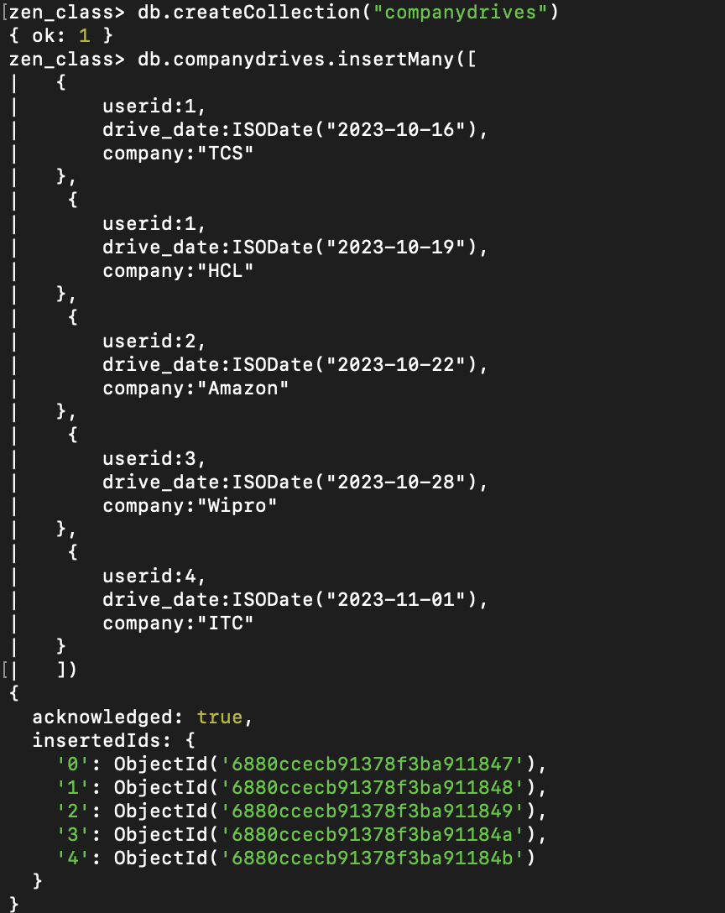
Collection Mentors:
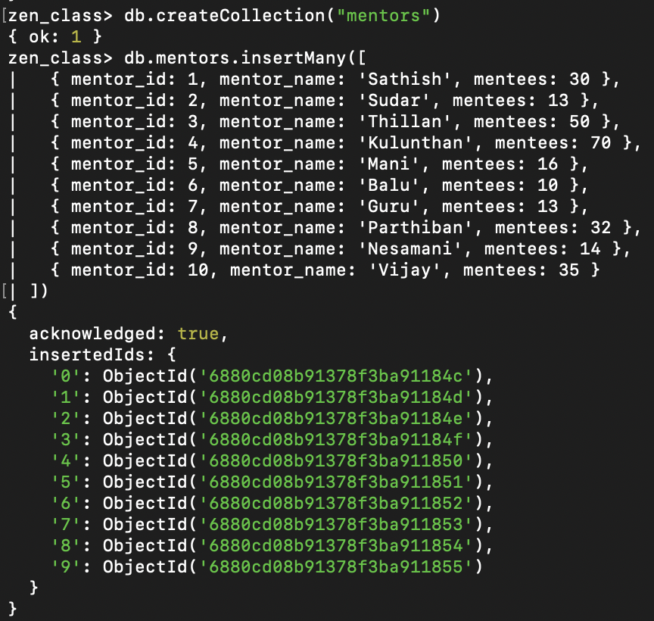

Collection Task_completion:
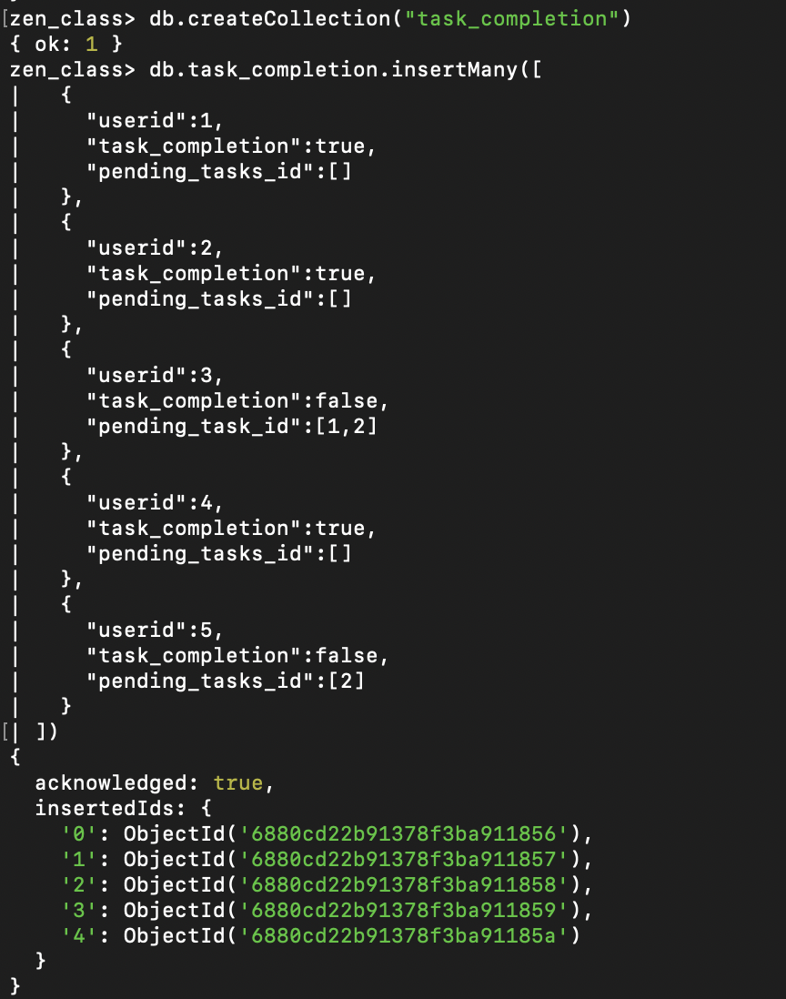
Collection Tasks:
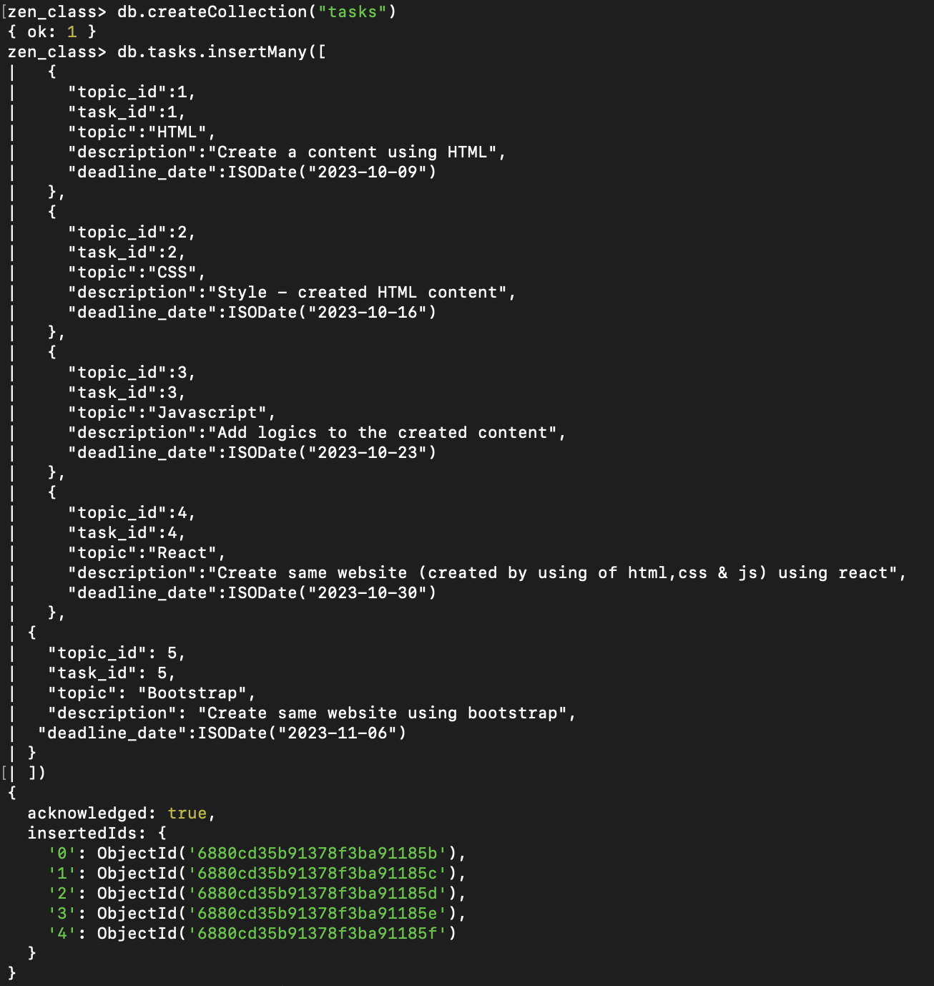

Collection Topics:
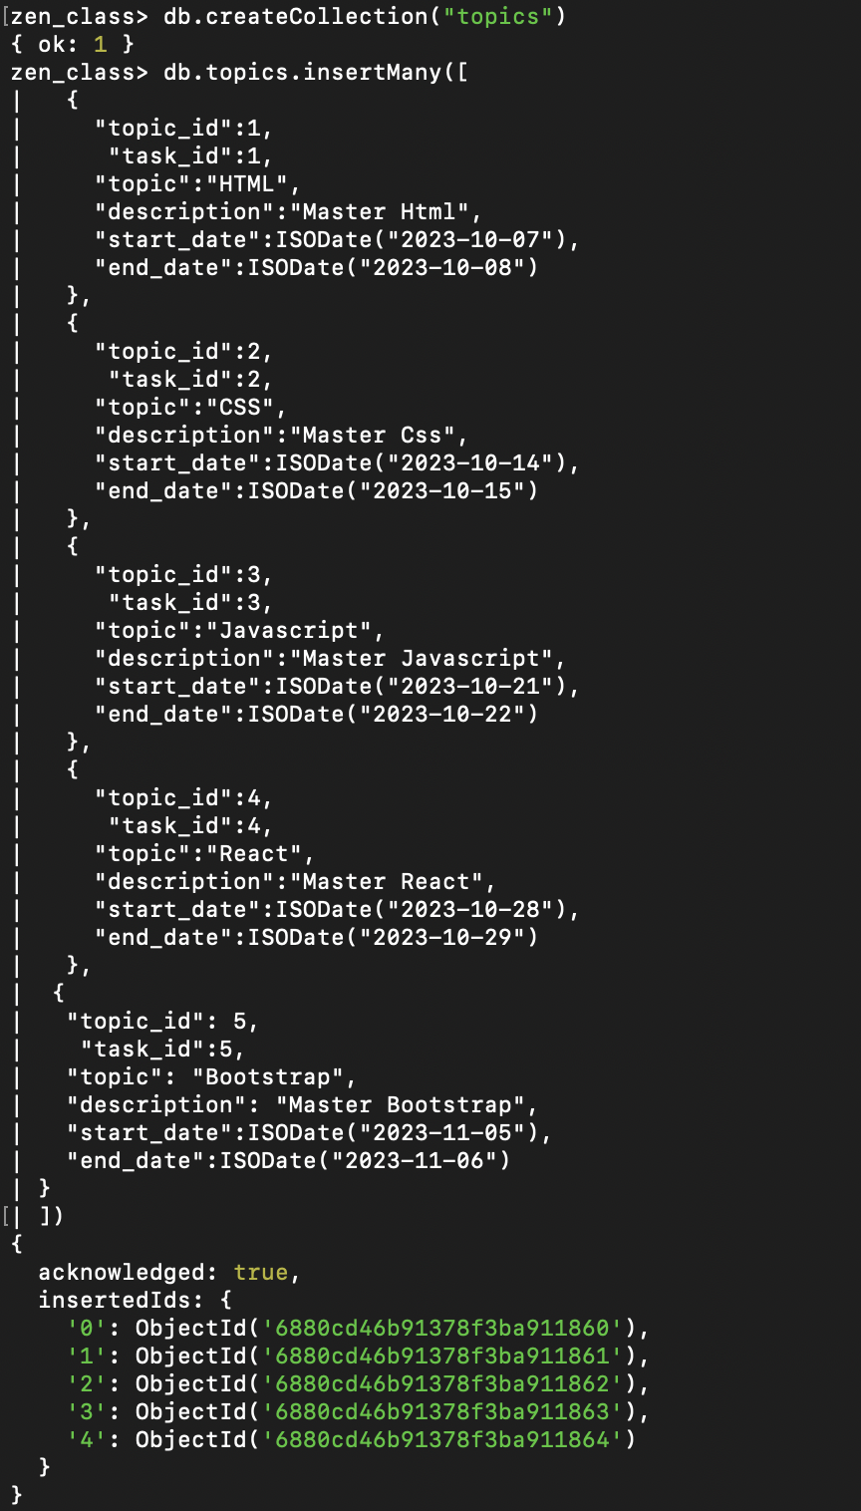
Collection Users:
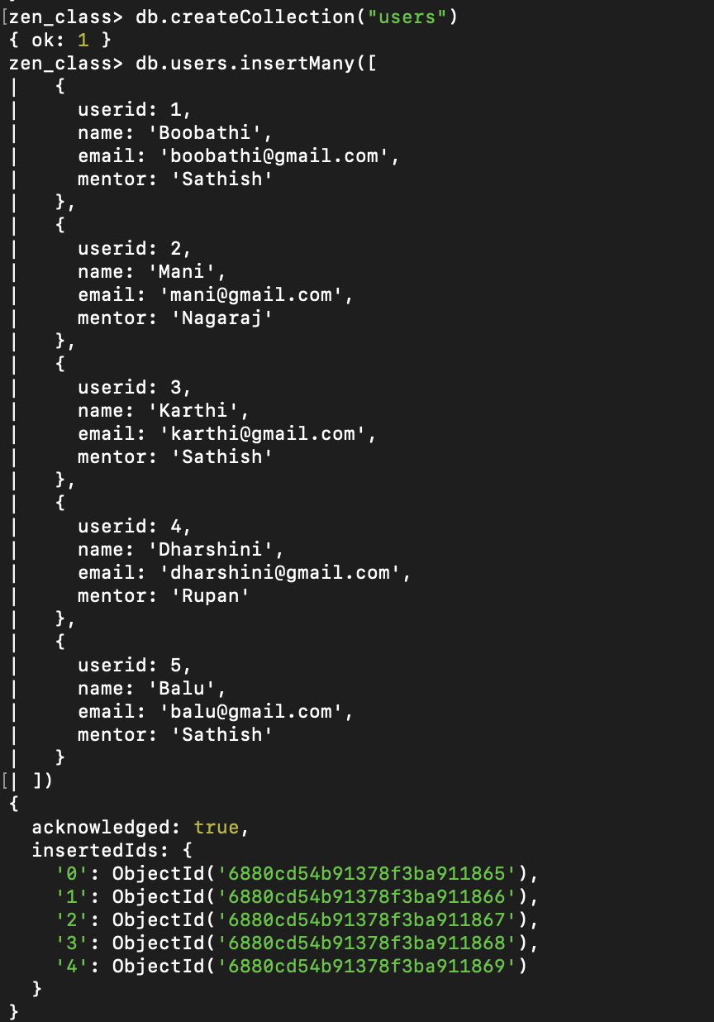

Show Collections:
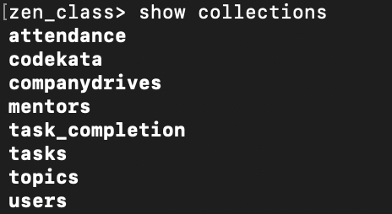

- Find all the topics and tasks which are thought in the month of October

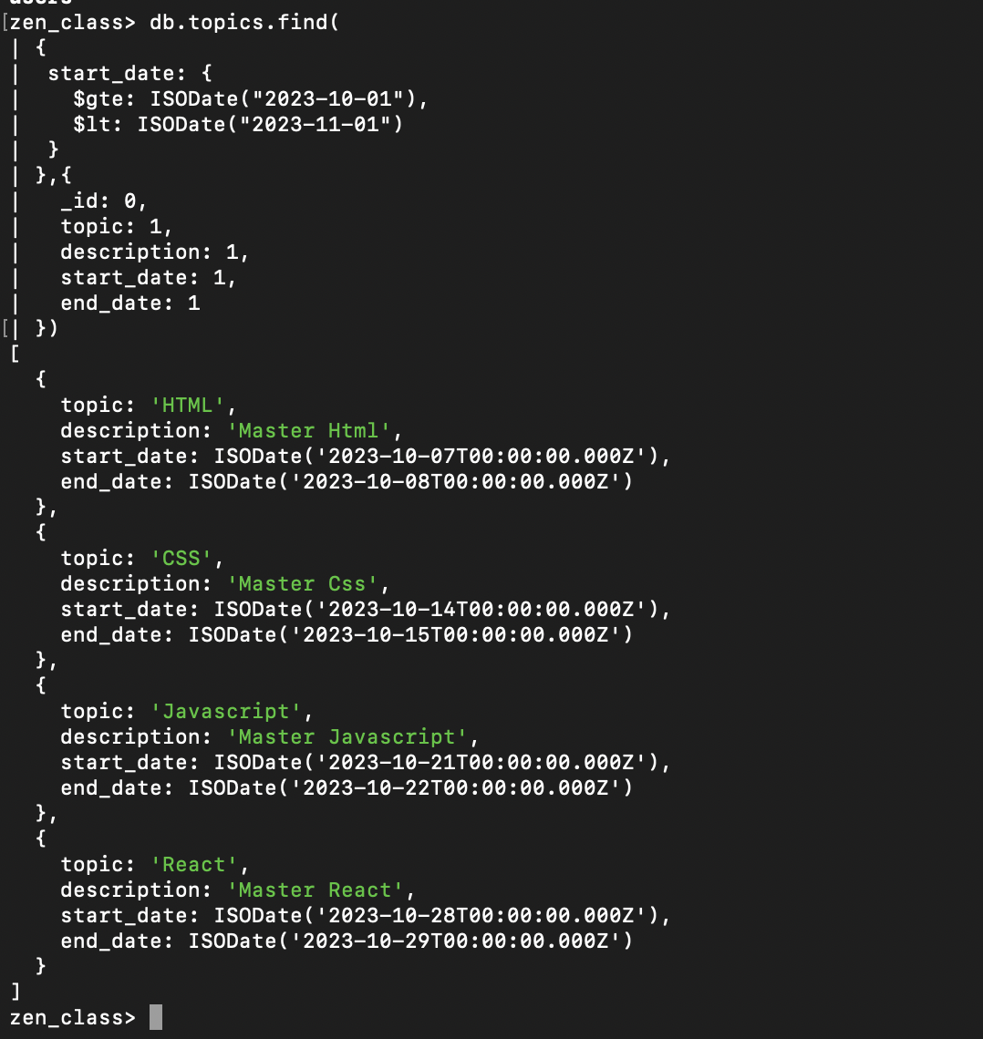

- Find all the company drives which appeared between 15 oct-2023 and 31-oct-2023

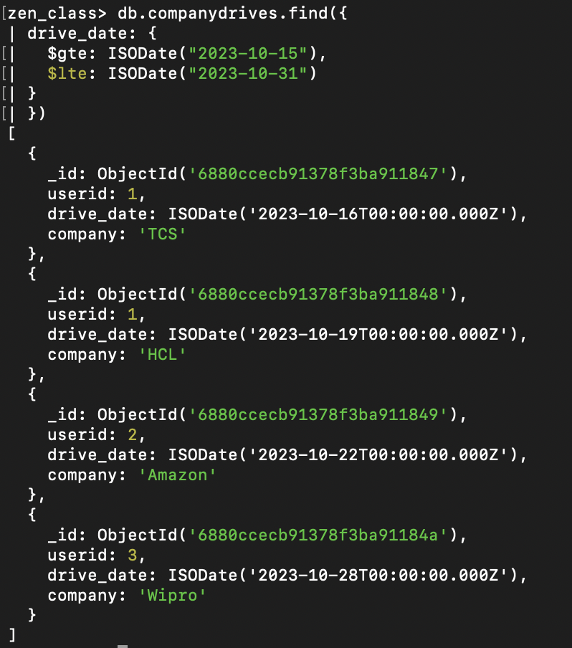

- Find the number of problems solved by the user in codekata

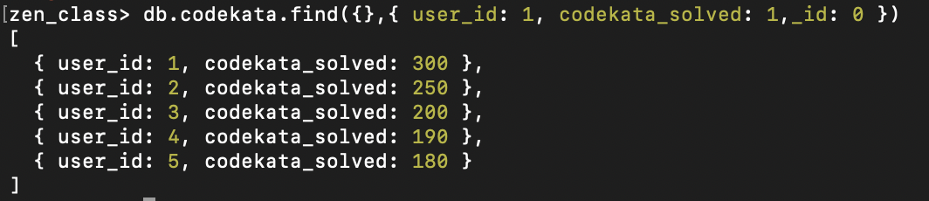

- Find all the mentors with who has the mentee's count more than 15
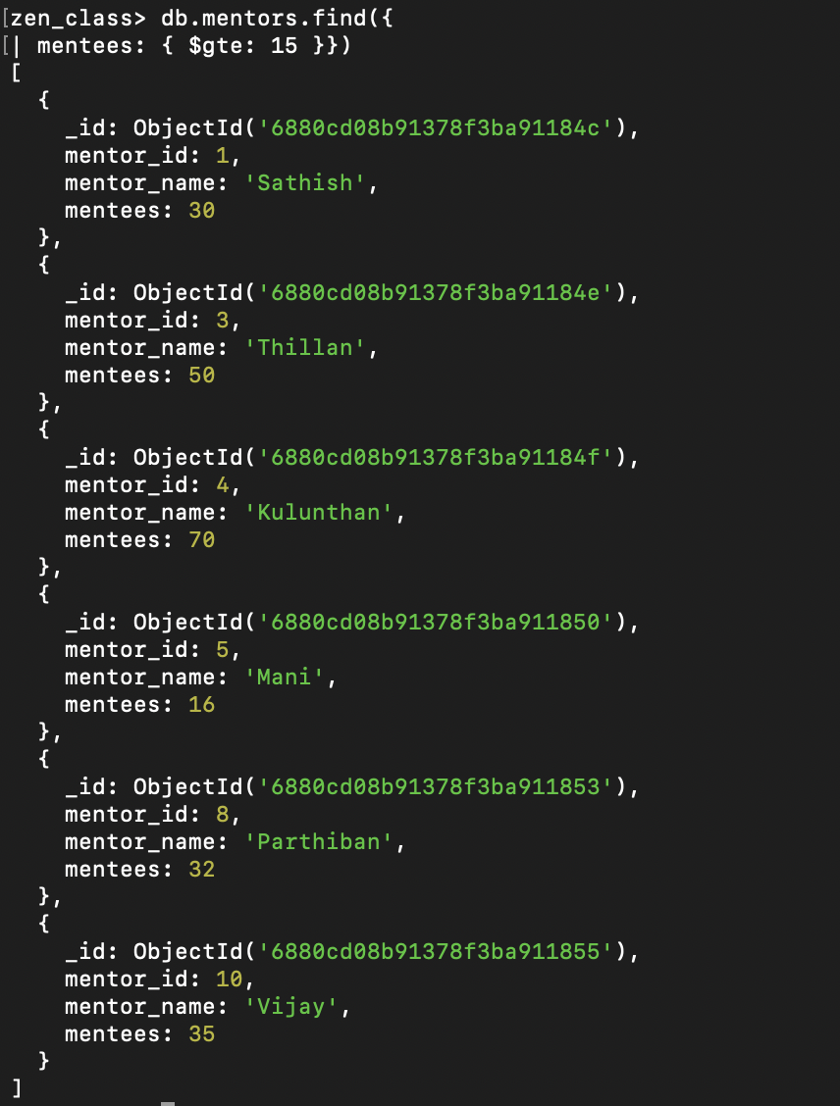

- Find the number of users who are absent and task is not submitted between 15 oct-2023 and 31-oct-2023

